CHAPTER 4

RESULT AND FINDINGS

This chapter explains the results and findings of the Centralized Web-Based System for Stress Induction Methods. This chapter cover all three phases of the project which are requirements gathering and analysis, system design, and project implementation process which focusing on the achieved and deliverables and to fulfil the objectives of the project.
4.1 Findings Requirements and Analysis Phase
In this phase, the primary activity is to gather all requirements for this project. Requirement was collected from Mr. Muhammad Hamiz bin Mohd Radzi, the researcher for stress research, help to understand the current research methodology, identify pain points, and determine the system features to ensure that the system follow the researcher requirement.
4.1.1 Conducting an Interview
To get all requirements accurately, a two-phase interview approach was performed. Phase 1 were focusing on the current problem and research methodology, while Phase 2 focused on technical requirements for the system. During the interview session, several questions were asked and recorded. Table 4.1 shows the results of this interview session.
Table 4.1 The analysis from the interview session with Mr. Hamiz
 | Question | Answer
1. | How are this stress tests currently implemented? | We use E-Prime for Stroop, a separate PowerPoint for TSST instructions, and a physical stopwatch for timing.
2. | How do you currently record participant responses and reaction times? | Stroop data is saved in a text file, but TSST arithmetic errors are recorded manually on paper by an observer.
3. | Should researchers be able to create multiple experiment templates, modify task parameters (time limit, difficulty, stimuli type), and save configurations for reuse? | Yes, templates are essential for standardization and repeating studies
4. | What user roles should the system support (e.g., Admin, Researcher, Participant), and what permissions should each have? | Admin manages users and study settings; Researchers configure studies and export data; Participants only take tests.
5. | Do you need digital informed consent and debriefing pages within the system? | We also need to store consent timestamp and version of the consent form.

Based on the interview session, Mr. Hamiz explained that the traditional approach required multiple change in platform and manual timing tools disrupt the experience flow and compromises data integrity. Furthermore, manual data transcription and the lack of synchronized video recording can create a human error and inefficiencies for researchers.
4.1.2 Analysed Requirements from Interview Session
All data was compiled for analysis and to create diagram based on the information obtained from the interview sessions. This included the System Sequence Diagram (SSD), Domain Class Diagram (DCD), and Use Case Diagram (UCD). The results of this requirements analysis are presented in Table 4.2.
Table 4.2 Requirement Gathering Result
 | Answer | Findings | Actor
1. | We use E-Prime for Stroop, a separate PowerPoint for TSST instructions, and a physical stopwatch for timing. Switching programs breaks the flow, allowing participant stress levels to drop. | A centralized, guided system that integrates the Stroop Test, MIST, and TSST into a single continuous web session.  Use case involved:  a) Perform Test | Participant
2. | Stroop data is saved in a text file, but TSST arithmetic errors are recorded manually on paper by an observer. Transcribing paper notes into Excel often leads to typos. | The system must automatically capture responses, score metrics (reaction time, errors), and securely synchronize timestamps with video feeds.  Use case involved:  a) View Result  b) Generate Report  c) Export Test Data | a) Administrator  b) Researcher
3. | Yes, templates are essential for standardization and repeating studies. | A template creation module that allows modification of task parameters (e.g., time limits, difficulty, stimuli types) and saves them for reuse.  Use case involved:  a) Manage Test | a) Administrator  b) Researcher
4. | Admin manages users and study settings; Researchers configure studies and export data; Participants only take tests. | A robust role-based access control (RBAC) system with distinct dashboards and permissions for each user type.  Use case involved:  a) Login  b) Create User Account  c) View User Account  d) Update User Account  e) Delete User Account | a) Administrator  b) Researcher
5. | We also need to store consent timestamp and version of the consent form. | An onboarding module that records the participant's consent timestamp and the specific version of the consent form used.  Use case involved:  - Choose Participant  -Manage Participant | a) Administrator  b) Researcher

Table 4.2 show every operational challenge identified during the interview has a targeted system solution. Three primary actors were identified for the Web-Based System for Stress Induction Method which are an Administrator to exclusively manage user accounts and overall system settings, a Researcher to manage test templates, handle participant records, and export data, and a Participant who accesses the system solely to perform the stress induction tasks.
4.1.3 Use Case Diagram
Based on the analyse requirements, the use case diagram has been created. The figure 4.1 shown the use case diagram for this project.
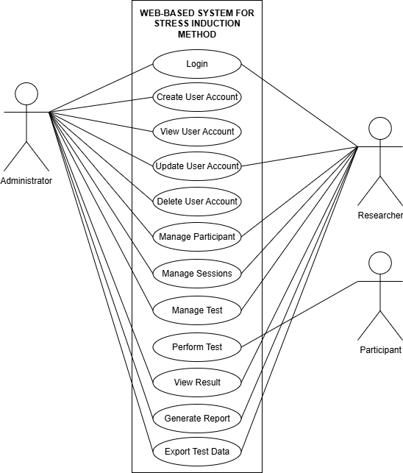
Figure 4.1 Use case diagram for Web-Based System for Stress Induction Methods
The use case diagram in Figure 4.1 shows a total of 9 use cases, with each actor having respective use case functions. Table 4.3 explains the function of each use case.

Table 4.3 Use Case Functionality
Actor | Use Case No. | Use Case | Description
Administrator, Researcher | UCD001 | Login | Allows the administrator and researcher to securely authenticate and access the platform's features.
Administrator | UCD002 | Create User Account | Enables the administrator to add new user access to the system.
Administrator | UCD003 | View User Account | Enables the administrator to view details of existing user accounts.
Administrator, Researcher | UCD004 | Update User Account | Enables the administrator and researcher to modify account details.
Administrator | UCD005 | Delete User Account | Enables the administrator to remove user access from the system.
Administrator, Researcher | UCD006 | Manage Participant | Allows for the secure management of participant and details.
Administrator, Researcher | UCD007 | Manage Sessions | Enables the management of testing schedules, timetables, and tracking which participants are registered to participate in specific sessions.
Administrator, Researcher | UCD008 | Manage Test | Allows the configuration, oversight, and active management of the specific stress induction tests assigned to a participant.
Administrator, Researcher | UCD009 | View Result | Enables the instant review of automatically captured metrics, such as reaction times and arithmetic errors, directly within the platform.
Administrator, Researcher | UCD010 | Generate Report | Allows the automatic compilation of participant performance into a structured, downloadable summary report.
Administrator, Researcher | UCD011 | Export Test Data | Enables the exporting of synchronized raw test data for external statistical analysis.
Participant | UCD012 | Perform Test | Allows the participant to undergo the assigned stress induction tasks within a single, continuous web session.

The use cases describe how these actors work with the system to accomplish different goals. Each use case is thoroughly described in the table, which also shows the relationship and procedures that are involved.
4.1.4 Activity Diagram
An activity diagram is used during the analysis phase to visually represent the sequence of tasks, actions, and procedures inside a system or a particular educational process. Figure 4.2 shows the sequential steps that needs to be follow successfully logging into the system and complete the registration process.
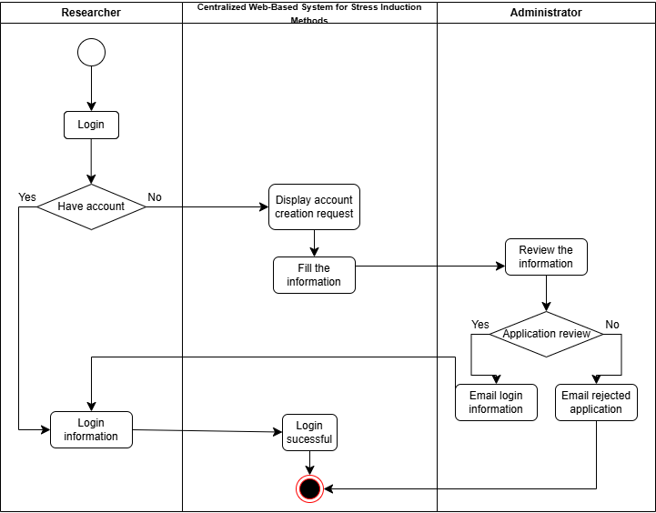
Figure 4.2 Activity diagram for login and registration for Researcher

Figure 4.2 illustrates the activity diagram for a researcher logging into or requesting an account for the system. The process begins with the researcher initiating the login process. If the researcher already has an account, they proceed directly to entering their login information, which giving the successful login by the system. If the researcher does not have an account, the system displays an account creation request. Once the required information is filled out, the administrator reviews the submitted details. If the administrator approves the application, administrator will email the login information to researcher, and if rejected, administrator emails a rejection email to researcher. Approved email can enter information to access the system.
4.1.5 Domain Class Diagram
The structure of this system is detailed in Domain Class Diagram (DCD) for this system, which shows all classes and their properties. It includes all essential components to understand how the system functions and interacts within its environment.
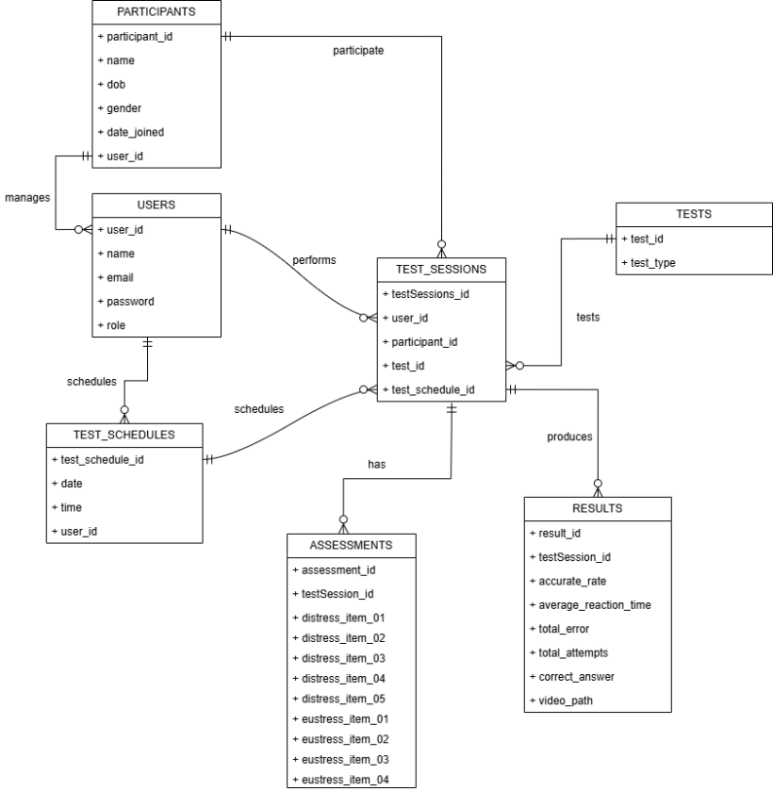
Figure 4.3 Domain Class Diagram
Figure 4.3 illustrates the relationship between different entities in the system. The user entity, which track the system purpose and status. Once registered, the User manages Participants entities, storing details like name, date of birth, gender, and date joined. The User also creates schedule in Test_Schedules. The Test_Sessions links multiple components togethers. Each Test_Sessions has Assessments to collect the pre-test and post-test which collected in scores consisting of distress and eustress items, and it produces Results that store performance such as accurate rate, average reaction time, total errors, total attempts, correct answers, and video paths.

4.1.6 System Sequence Diagram
A sequence diagram is showing how each part of the things works in order. Showing the details of tasks.
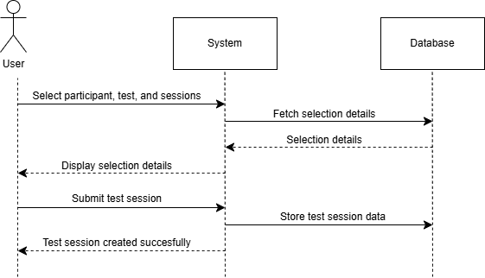
Figure 4.4 System sequence diagram for create test session
Figure 4.4 illustrates the system sequence diagram for creating a test session. The process begins when the User selects a participant, a specific test, and sessions. The System fetches the corresponding details from the Database and displays them back to the User. After confirming the selections, the User submits the test session registration. The System then sends the information to be stored in the Database, which creates the new test session record. Finally, the System displays a successful creation message to the User, completing the process.
4.2 Findings of System Design
Following the collection and analysis of requirements, comes the design phase. This phase consists of three main tasks: creating the system's initial storyboard, creating the system's diagrams, and combining all the system designs into a single document known as the Software Design Documentation. The system's diagrams comprise a use case diagram, activity diagram, domain class diagram, and system sequence diagram.
4.2.1 Multilayer Sequence Diagram
The study, design, and stakeholder communication of complex systems with several interacting components benefit greatly from the use of multilayer sequence diagrams. It accomplishes this by assisting in the multi-layered visualization of the data or control flow. Furthermore, these kinds of diagrams facilitate the process of converting design concepts into functional components and confirming their interrelationships during the testing and implementation stages.
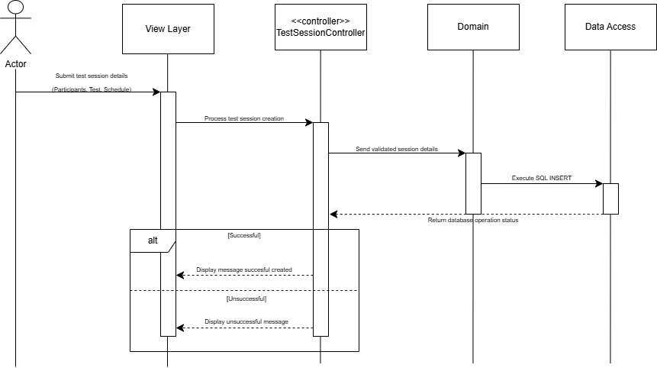
Figure 4.5 Multilayer sequence diagram
Figure 4.5 illustrates the process of a user creating a test session in a multilayer system. The user first interacts through the View Layer by submitting the selected participant, test, and schedule details. The View Layer sends this request to the TestSessionController to process the creation. The TestSessionController then sends the validated test session details to the Domain Layer. From there, the data moves to the Data Access Layer, where an SQL INSERT query is used to store the new test session record in the database. Once the creation is processed, the system sends a success or failure message back to the View Layer, notifying the user of the result.
4.2.2 Entity Relationships Diagram
Entity Relationships Diagram (ERD) is a graphic depiction of a data model that shows how entities in a system relate to one another. It is frequently used in database design to show the relationships between each element. Figure 4.6 below shows the ERD diagram for the system.
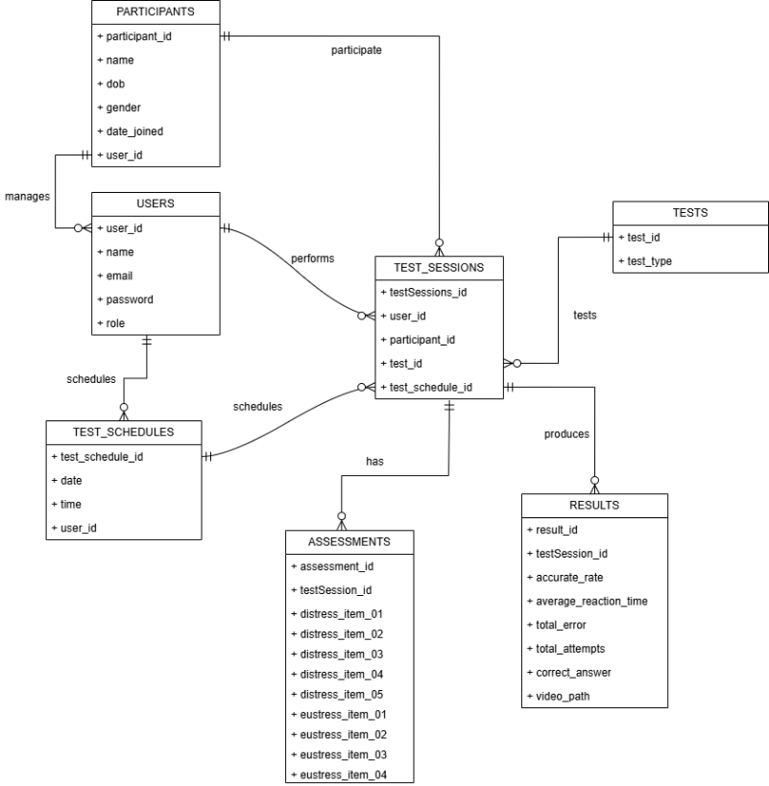
Figure 4.6 Entity Relationships Diagram
Figure 4.6 shows the ERD of the system consisting of several entities such as USERS, PARTICIPANTS, TEST_SCHEDULES, TESTS, TEST_SESSIONS, ASSESSMENT, AND RESULT. Users (such as researchers) can manage multiple participants, and each participant record is linked to one specific user account. Users also create and manage multiple test session.
4.2.3 Package Diagram
In UML (Unified Modelling Language), a package diagram shows a high-level representation for the system structure. Showing related elements such as, classes, interfaces, or use cases, into a package to form a unified unit. The package diagram in Figure 4.7 below shows the dependency relationship between each package.

4.3 Result of Implementation Phase
4.3.1 User Interface of the System
The interfaces that will be shown next are listed below:
- Landing Page
- Login
- Researcher Registration
- Dashboard Page
4.5 Result Findings
4.5.1 Analysis from Interview Phase 1
4.5.2 Analysis from Interview Phase 2
4.6 Summary

